Integration Test Plan

For

Sale System

Submitted by

BnD Team

Introduction

Purpose
The purpose of the integration test plan is to describe the necessary tests to verify that all of the components of Sale System are properly assembled. Integration testing ensures that the unit-tested modules interact correctly.

Scope
Sale System allows consumers to manage the inventory and cost . It control the process of selling , purchasing and other inventory flow like invoice , purchase bill , adjust stock etc.

The Sale System also allow customer to manage fixed asset value and movement. Over there we include the two processes are maintenance service and rental fixed assets

Architecture Description

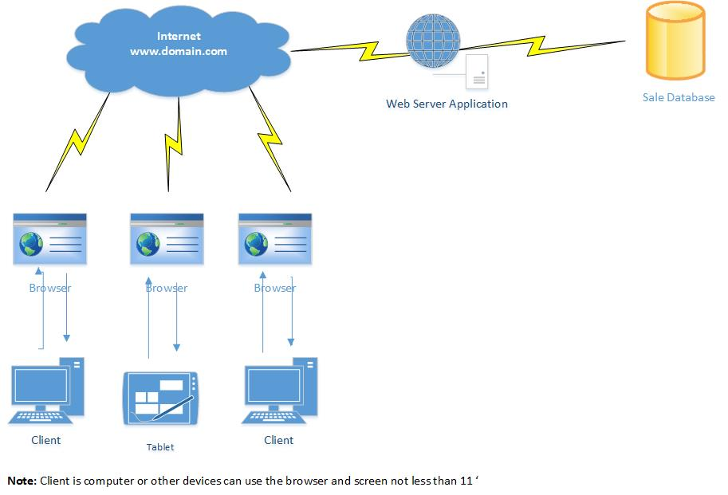

Integration Tests

Opening inventory and fixed asset item
Purpose | Insert beginning balance before the transaction into the system to use.

External Dependencies
Test Description | 1) Create inventory and fixed assets item  2) prepare opening stock document  3) go to opening module and book it into the system
Expected Results | After transaction we balance in stock for use .

Transfer inventory item refer to which requisition
Purpose | Transfer product from one location to others location with requisition .It happen when one location need product for use

External Dependencies
Test Description | 1) Create stock requisition of product  2) Make transferring product by selecting which requisition  3) Select product to transfer  4) Submit
Expected Results | After transferred the location that received product have product for use and the requisition is closed.

Transfer item fixed assets item without requisition
Purpose | Move fixed assets from one location to other location

External Dependencies
Test Description | 1) Create stock requisition of product  2) Make transferring product by selecting which requisition  3) Select product to transfer or input fixed assets code in the box  4) Submit
Expected Results | After transfer we can see fixed asset change location .

Adjust inventory
Purpose | To adjust quantity of product when we got the actual result.

External Dependencies
Test Description | - Go to adjust stock module  - Select product to adjust  - Input actual quantity  - Select type of adjustment  - Submit
Expected Results | The result may be increase or decrease .

Adjust fixed assets
Purpose | To adjust fixed assets status when we got the actual result ( Active or Inactive)

External Dependencies
Test Description | - Go to adjust stock module  - Select product to adjust  - Input actual quantity  - Select type of adjustment  - Submit
Expected Results | The result may be inactive of fixed assets

Create Quotation
Purpose | Issue quotation for customer

External Dependencies
Test Description | - Select product to issue  - Submit.
Expected Results | After we create will get the quotation is pending the approval.

Create Invoice
Purpose | Issue invoice for customer of selling product

External Dependencies
Test Description | - Select product to sale  - Submit
Expected Results | - Generate invoice for customer  - If sale inventory so reduce from stock  - If sale fixed asset so will update fixed asset as inactive  - Can print out immediately

Create Invoice reference of a quotation

Purpose | Issue invoice for customer of selling product

External Dependencies
Test Description | - Select quotation  - Select product to sale  - Submit
Expected Results | - Generate invoice for customer  - If sale inventory so reduce from stock  - If sale fixed asset so will update fixed asset as inactive  - Can print out immediately  - Update quotation status is completed

Create receipt of customer payment
Purpose | Receive payment from customer

External Dependencies
Test Description | - Select quotation  - Select invoice to pay  - Input amount  - Submit
Expected Results | - Generate receipt for customer  - If full payment so will update sale payment status of invoice is Full Paid  - If full payment so will update sale payment status of invoice is  If full payment so will update sale payment status of invoice is Partial Paid

